📘 Types of Homographs
# Source: Chatgpt (GPT-4-turbo) at [8/1/2025]
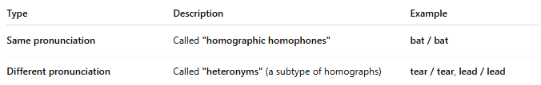
Type | Description | Example
Same pronunciation | Called "homographic homophones" | bat / bat
Different pronunciation | Called "heteronyms" (a subtype of homographs) | tear / tear, lead / lead

